SOC Workbooks and Lookups - Lab Report

Date: 30/06/2026
Difficulty: Easy
Category: SOC Team Internals
Platform: TryHackMe

Overview

This lab discusses how SOC analysts use Workbooks to help them investigate and come to a decision on an alert. It also looks at how more information can be gathered such as identity inventory, asset inventory and network diagrams.

2. What I did

Identity inventory is a catalogue of corporate employees (user accounts), services (machine accounts and their details such as contacts, role within the company and privileges. These can be found in active directory, SSO providers (Google workspace), HR systems or custom solutions such as CSV or Excel sheets.

Asset inventory or asset lookup is a list of all computing resources within an organisations IT environment. These can be found in Active directory, SIEM or EDR solutions, MDM solutions or custom solutions like Excel sheets.

To investigate alerts from a network view, you can use a network diagram which gives valuable information about locations, users/IPs, subnets and connections. It depends on the size of the company as to how detailed and complex the diagram could be.

SOC workbooks also known as playbooks, runbooks or workflow are structured documents that define the steps required to investigate and fix specific threats consistently. Level 1 analysts are advised to use these workbooks to avoid mistakes and streamline all analysis. Below is an example of a workbook for unusual login location.

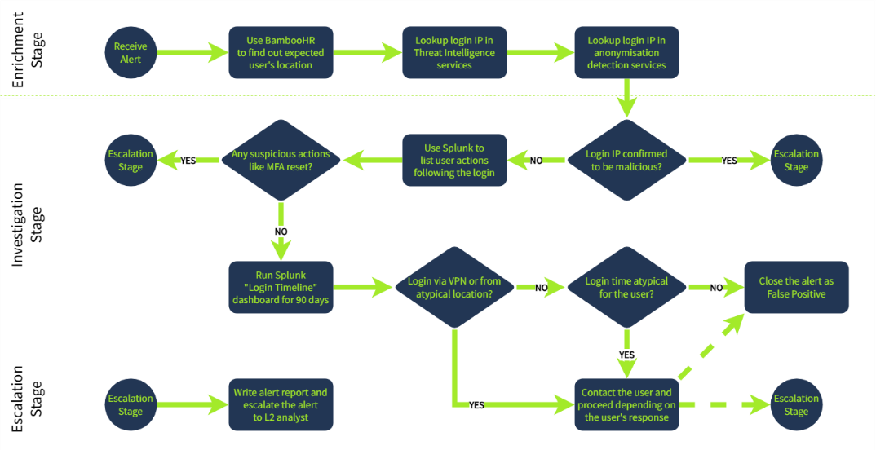

Enrichment uses threat intelligence and identity inventory to get information about the affected user, investigation means using gathered data and SIEM logs to make your final verdict and finally escalation is escalation is escalating the alert to level 2 analysts or communicate the login with the user if appropriate.

3. What I’ve learned

- What Workbooks are
- What a workbook looks like
- How more information can be gathered

